
HUMAN BIOLOGICAL SCIENCE
WHAT IS HUMAN BIOLOGY?
Human biological science
WHAT IS SCIENCE?
- Science is a – a way of finding out about human beings and their living and non-living surroundings.
- Science is a – gained by
HUMAN BIOLOGICAL SCIENCE sources its knowledge .

HOW DO SCIENTISTS INVESTIGATE?
The scientist and then to that problem.
- Literature review –
- Observation –
- Classifying –
- Experimentation
  - Propose a that can be tested to find data that the hypothesis
  - Test at a time
  - For data to be valid, the
  - Factors that may provide need to be eliminated – these are called
HOW DO SCIENTISTS AVOID BIAS AND ERROR?
- OBJECTIVITY – not allowing to influence the recording or interpretation of observations.
  - Recording actual measurements of observations ( ) rather than personal judgements of the degree of change being observed ( ).
  - If qualitative data are used, a reference chart that prescribes how the judgements were made can be used.
- VALIDITY AND RELIABILITY OF RESULTS
  - Validity – the experiment ; all variables are
  - Reliability – the experiment – measuring instruments are calibrated and accurate – confirms if the experiment is reliable
  - Peer review – results are so that other scientists can examine the results .
MAKING SENSE OF DATA
Data - Observations and measurements collected during a scientific investigation – often displayed in
- T – organised lists of data, particularly useful for displaying .
- G - make it easy to see trends and make predictions (see Chapter 2)
N – use of allows for comparisons (Add up all the data values and divide by the number of measurements); eliminates the , the extreme measurements that are well beyond the range of the other measurements that will affect means.
Ratios and rates
- Ratios - – for example Surface Area to Volume Ratio – the
- Rate – the measurement of a value – for example heart rate is measured in
- Percentages – means
  - Percentage change – allows a comparison between then and now to quantify by how much something has changed
- Frequencies – the – often displayed on a
HOW DO SCIENTISTS REPORT THEIR FINDINGS?
- REPORTS –
- CONFERENCES – scientists present
- PEER REVIEW – papers are published

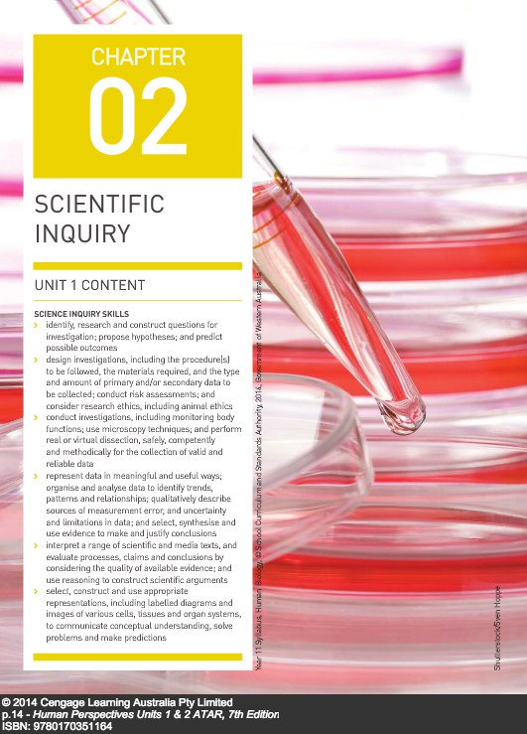

SCIENTIFIC METHOD
- A .
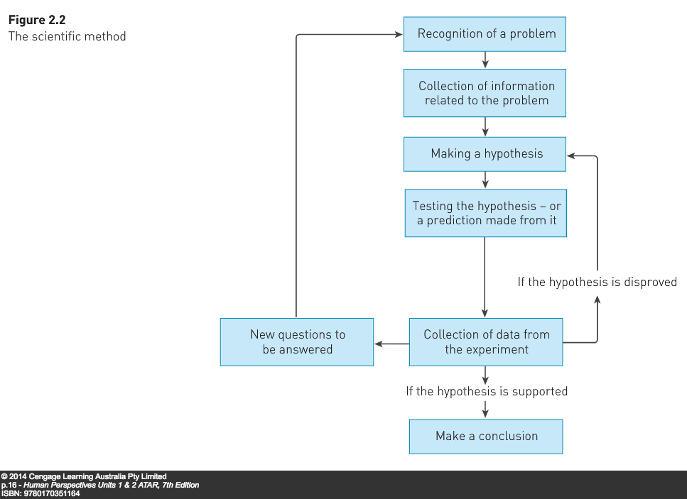
- P .

- Recognition and definition of the problem – . This results in the – Pasteur: “ ?”
- Gathering information enabled him to formulate a : .
- The next step is to the hypothesis, or a prediction made from the hypothesis, .
- As the experiment proceeds, the .
- After all the data are recorded, the scientist makes of the data, deciding whether the data .
- Once the scientist has made this decision, they can .
- PLEASE NOTE: The results of an experiment .
HYPOTHESES
A .
A good hypothesis:
- Is : “Microbes in the air cause fermentation in broth.”
- Is
- Refers
- Links : “Microbes in the air (independent variable)…cause fermentation in broth (dependent variable)

CASE IN POINT: Does an increase in exercise cause heart rate to increase?
3 valid hypotheses are possible for most questions raised for investigation:
- An increase in exercise .
- An increase in exercise .
- An increase in exercise .

Each of these is a .
DESIGNING EXPERIMENTS
Experiments must be designed so that the results will .
To do this:
- Only factor, or variable, is tested at a time.
- A is conducted in which the only difference is the . For example, in “An increase in exercise causes an increase in heart rate”, the control experiment would involve checking the heart rate of subjects who do not increase their exercise.
- Such an experiment involving an and an appropriate is known as a .
- Where applicable, it involves the use of instruments that provide . Measurements are and easier than descriptions of observations.

VARIABLES
Definition:
Independent variable:
Dependent variable:
Controlled variables:
Uncontrolled variables:
Scientific experiments always involve . This may mean:
- Doing , or
- Performing the same experiment on .
Having a large is particularly important for the . This large sample size helps to eliminate the variations that can be introduced by outliers. Sample sizes for investigations involving humans often run into the for this reason.
DESIGNING EXPERIMENTS: EXPERIMENTAL ERROR
Results of experiments always contain errors.
To account for this, scientists will often state “ …” or “ …”
Three possible types of errors:
- Human errors – . These are not included as experimental error.
- Random errors – small errors in the that provide variations in the data; for example the small variations that will occur in using a stopwatch; these are not human errors but .
- Systematic errors – occur because of the way in which so measurements will always be – requires the changing of the .
To eliminate sources of error, the experiment must be designed .
Reporting requires acknowledgement of the .

INVESTIGATING HUMANS
ETHICAL CONSIDERATIONS
Ethics: a set of
Ethical behaviour: behaviour that conforms to moral values and principles
Scientific research, particularly involving human participants, often involves ethical issues. Ethics committees in Australian universities ensure that scientific research is undertaken through ethical standards. Australian schools and universities are also monitored regarding the ethical use and confinement of animals during their research.
Ethical principles that must be satisfied during an investigation include:
- Voluntary participation – .
- Informed consent – participants informed about the objectives of the research, procedures, risks and benefits. .
- Risk of harm – some procedures may involve harm but this .
- Confidentiality - identities of participants .
- Anonymity – .

PLACEBOS:
- Used in research into new medications
- An
- The experimental group and the .
- Subjects .
- Doesn’t have to be a tablet; can be any “dummy” treatment such as .
- Patients given placebos often show improvement; called the .
- Placebo experiments are often where ; double-blind experiments occur .
- Reduces the risk of bias.
PRESENTATION OF DATA
TABLES - Organized and concise ways of presenting data
Rules for tables
- T – “Table showing heart rate with increasing exercise time”.
- Data
- Each column

GRAPHS: Useful ways of presenting data
- Independent variable ; dependent variable .
- Label the axes with
- Indicate
- Give the graph a title that summarizes – “Graph of heart rate with increasing exercise time”
- Use on each axis
- Appropriate size –
- Appropriate type
  - Line graph – ; in human biology, .
  - Bar or column graph – ; contain spaces between columns
  - Histograms – used to show – how often a . Population pyramids are histograms.
APPLICATION OF THE SCIENTIFIC METHOD

- Insert the following words to complete the sentences below:-

Observations | Prediction | Experimental  variable | Biologists
Support | Theory | Scientists | Communicate
Inference | Replicates | Scientific method | Hypothesis
Graph | Sample size | Table | Reliability
Science | Evidence | Controlled experiment | Repeat
Data | Disprove | Variables | Random
Conclusion | Records | Analysed | Proved

a) seek solutions to problems which relate to the living world & use scientific processes which lead to the discovery of new knowledge.
b) Through their investigations, biologists and other try to answer questions posed by of the world around them.They approach problems in a step by step manner known as the
.
c) When a scientist or biologist tries to give an explanation for an observation, they are making an . He then guesses what will happen so he is making a .
d) To test whether this prediction is accurate the biologist then formulates an , a tentative explanation or educated guess. This must contain only one idea and be a definite statement.
e) This hypothesis can be tested in a scientific way by means of a , where all are kept constant except for one. This one factor is deliberately altered and is known as the .
f) If the experiment is carefully designed, then a large , many, and samples should be used. To further improve accuracy and of results, a scientist should the experiment.
g) Scientists must with other scientists by keeping accurate of the experiment.

h) In an experiment, the scientist records often in form. Sometimes these results can be drawn into a . The results are then to see if they or the hypothesis. This is called the of the experiment.
I) An hypothesis cannot be no matter how many times it has been tested. If an hypothesis, however, has been supported by a large body of different types of observations and experiments, it becomes a . There are no certainties in as new may arise some time in the future due to more research and experimentation.

Multiple choice questions:
1. Which of the following is the best description of a scientific hypothesis?
a) an idea that is accepted by most scientists
b) a principle that applies in a number of situations
c) a statement that can be tested.
d) a suggested explanation for observations.

2. To test the effectiveness of a new drug designed to treat bone cancer, a researcher selected 47 bone cancer patients. During the three year trial period, about half of the patients were to be given the new drug while the remainder were to be treated by normal treatment.
The experiment is controlled by:
a) the large number of 47 patients
b) administration of the new drug
c) the group receiving the normal treatment.
d) ensuring that all patients had the same medical history

3. A controlled experiment is one which
a) all variables are controlled
b) all variables are kept constant
c) there are no variables
d) all variables except one are kept constant.

4. While examining drops of fluid containing bacteria which form butanoic acid, Louis Pasteur noticed that when the organisms came near the edge of a drop they stopped moving.
The process in which Pasteur was involved is best described as
a) forming a hypothesis
b) observation
c) inference
d) forming a conclusion

5. Pasteur suggested that the oxygen in the air, near the edge of the drop, may have stopped the bacteria moving. The process involved in making the suggestion is best described as-
a) making a generalisation
b) reaching a conclusion
c) developing a theory
d) forming a hypothesis

6. A researcher was testing the hypothesis: “the range of sound frequencies that a person can hear decreases with age”. She selected a number of subjects, both male and female, of differing ages. A sound generator was used to expose the subjects to sounds of varying frequencies over a range of volumes. The dependent variable in this experiment was the-
a) age of subjects
b) volume of sound
c) frequency of the sound
d) frequency range detected by the subjects

7. In graphing the results of the experiment described in question 6, the student should use:-
a) a line graph and plot sound frequency on the x-axis & age on the y-axis
b) a line graph and plot age on the x-axis & sound frequency on the y-axis
c) a histogram and plot sound frequency on the x-axis & age on the y-axis
d) a histogram and plot age on the x-axis & sound frequency on the y-axis

8. A group of year 12 Human Biology students were planning an experiment to try to find out the effects of exercise on heart & breathing rate. They decided to measure heart and breathing rate of 10 students before and after exercise. The independent variable in this experiment is the:
a) heart rate
b) breathing rate
c) heart& breathing rate
d) exercise

9. A scientist carried out an experiment to measure the effect of alcohol on people's reaction time. A group of similar height, weight and age were given a non-alcoholic drink and were timed how long it took them to press a buzzer after seeing a red light. The procedure was repeated with the same students with their reaction times being measured after they had drunk 1,2& 3 standard alcohol drinks. The controlled variables in the above experiment were-
a) pressing the buzzer
b) the height, weight & age
c) reaction times
d) the number of alcoholic drinks

10. Which alternative below correctly shows the independent and the dependent variable from question 9?
 | Independent | Dependent
a) | Height, weight, age | Amount of alcohol
b) | Reaction time | Amount of alcohol
c) | no. of students | Reaction time
d) | Amount of alcohol | Reaction time

11. Which of the following is the most suitable hypothesis that was being tested in this experiment?
a) male students have a fast reaction time
b) alcohol affects reaction time
c) as alcohol intake increases, reaction time increases
d) reaction time is not affected by alcohol

12. An experiment was conducted to investigate the effect of increased temperature on sweating rate. The data below shows the sweat rate and temperature relationship.
Table of the effect of increased temperature on sweating rate.
Temperature (degrees celsius) | Sweat rate (mL/ hour)
35 | 2.5
38 | 2.6
39 | 3.15
41 | 3.6
45 | 4.25

a) Plot a graph in the grid below to display the above data

b) Write an hypothesis for the experiment:-
c) What is the independent variable?
d) What is the dependent variable?
e) Would a prediction of the sweat rate at 40 degrees be likely to be more or less accurate than the sweat rate at 48 degrees? Explain.

13. Background information:

In recent years there has been much controversy surrounding the relative merits of various fats and oils in controlling cholesterol levels. One of the more recent contenders is palm oil. This is surprising, since palm oil is a saturated oil which is not normally recommended for people with high cholesterol levels. It is claimed, however, that recent tests have shown that a regular intake of palm oil can reduce cholesterol levels by as much as 15%.

- Design a simple, controlled experiment to test this claim.

1. What is the dependent variable?
2. What is the independent variable?
3. What is an appropriate hypothesis?
4. List some other variables that need to be controlled to ensure validity:-

5. How will you set up the control & experimental groups to ensure that the above variables do not interfere with the dependent variable?

6. What data will support the hypothesis?

7. What should you do to minimise measurement & sampling errors?

Complete the table below for each hypothesis
Hypothesis | Independent variable | Dependent variable | Controlled variables | Experimental Group | Control Group
Laying babies on their backs to sleep reduces the incidence of SIDS
Gastric protease digests egg white faster than pancreatic protease
Smoking increases the risk of prostate cancer in males
Vaccinations for cervical cancer reduce the incidence of cervical cancer in females
Decaffeinated coffee lowers cholesterol
Patients in a coma come out of the coma more quickly if people talk to them

Scientific Method In Action
The Strange Case of BeriBeri

In 1887 a strange nerve disease attacked the people in the Dutch East Indies. The disease was beriberi. Symptoms of the disease included weakness and loss of appetite, victims often died of heart failure. Scientists thought the disease might be caused by bacteria. They injected chickens with bacteria from the blood of patients with beriberi. The injected chickens became sick. However, so did a group of chickens that were not injected with bacteria.
One of the scientists, Dr. Eijkman, noticed something. Before the experiment, all the chickens had eaten whole-grain rice, but during the experiment, the chickens were fed polished rice. Dr. Eijkman researched this interesting case. he found that polished rice lacked thiamine, a vitamin necessary for good health.

Complete the following:

1. State the Problem-
2. What was the hypothesis?
3. How was the hypothesis tested?
4. Should the hypothesis be supported or rejected based on the experiment?
5. What should be the new hypothesis?

How Penicillin Was Discovered
In 1928, Sir Alexander Fleming was studying Staphylococcus bacteria growing in culture dishes. He noticed that a mold called Penicillium was also growing in some of the dishes. A clear area existed around the mold because all the bacteria that had grown in this area had died. In the culture dishes without the mold, no clear areas were present.
Fleming hypothesized that the mold must be producing a chemical that killed the bacteria. He decided to isolate this substance and test it to see if it would kill bacteria. Fleming transferred the mold to a nutrient broth solution. This solution contained all the materials the mold needed to grow. After the mold grew, he removed it from the nutrient broth. Fleming then added the nutrient broth in which the mold had grown to a culture of bacteria. He observed that the bacteria died.

1. Identify the problem-
2. What was Fleming's hypothesis?
3. How was the hypothesis tested?
4. Should the hypothesis be supported or rejected based on the experiment?
5. This experiment led to the development of what major medical advancement?

Identify the Controls and Variables
  Smithers thinks that a special juice will increase the productivity of workers. He creates two groups of 50 workers each and assigns each group the same task (in this case, they're supposed to staple a set of papers). Group A is given the special juice to drink while they work. Group B is not given the special juice. After an hour, Smithers counts how many stacks of papers each group has made. Group A made 1,587 stacks, Group B made 2,113 stacks. | Identify the:  1. Control Group  2. Independent Variable  3. Dependent Variable  4. What should Smithers' conclusion be?  5. How could this experiment be improved?
  Homer notices that his shower is covered in a strange green slime. His friend Barney tells him that coconut juice will get rid of the green slime. Homer decides to check this this out by spraying half of the shower with coconut juice. He sprays the other half of the shower with water. After 3 days of "treatment" there is no change in the appearance of the green slime on either side of the shower. | 6. What was the iniitial observation?  Identify the-  7. Control Group  8. Independent Variable  9. Dependent Variable  10. What should Homer's conclusion be?

  Bart believes that mice exposed to microwaves will become extra strong (maybe he's been reading too much Radioactive Man). He decides to perform this experiment by placing 10 mice in a microwave for 10 seconds. He compared these 10 mice to another 10 mice that had not been exposed. His test consisted of a heavy block of wood that blocked the mouse food. he found that 8 out of 10 of the microwaved mice were able to push the block away. 7 out of 10 of the non-microwaved mice were able to do the same. | Identify the-  11. Control Group  12. Independent Variable  13. Dependent Variable  14. What should Bart's conclusion be?  15. How could Bart's experiment be improved?
  Krusty was told that a certain itching powder was the newest best thing on the market, it even claims to cause 50% longer lasting itches. Interested in this product, he buys the itching powder and compares it to his usual product. One test subject (A) is sprinkled with the original itching powder, and another test subject (B) was sprinkled with the Experimental itching powder. Subject A reported having itches for 30 minutes. Subject B reported to have itches for 45 minutes. | Identify the-  16. Control Group  17. Independent Variable  18. Dependent Variable  19. Explain whether the data supports the advertisements claims about its product.
  Lisa is working on a science project. Her task is to answer the question: "Does Rogooti (which is a commercial hair product) affect the speed of hair growth?” Her family is willing to volunteer for the experiment. | 20. Describe how Lisa would perform this experiment. Identify the control group, and the independent and dependent variables in your description.

